

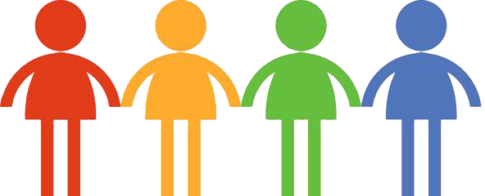

- NDAS is not a support or intervention service. Understanding and support can be enhanced by a diagnosis but should not be dependent on, or wait for, a diagnosis. It is important to give support which has been put in place time to work.

- If there are still concerns and you are seeking a diagnosis a discussion should take place between you, the child or young person, and the teacher or professional involved.

- If it is thought there may be a possible neurodevelopmental disorder you and the young person will be asked for consent for this to be discussed with someone from the NDAS team in a pre-request discussion.

- If it is agreed an assessment may be appropriate you will be asked to submit further information and a consent form. This will be considered by the team during triage.

- The NDAS team will then decide whether the request is appropriate for the service, and if so which professionals should be involved in the assessment. You will be informed of this decision. Further questionnaires may be sent out if more information is needed.

- Appointments could take place in a variety of clinic settings and/ or by video link. School observations and home visits may be arranged if appropriate.

- Speak with staff at your School, or Professionals you may already be involved with.

- Alternatively, you can contact us directly for advice by emailing nhsh.nds@nhs.scot .

What can you expect?
Information for Parents and Carers
Version 20/07/21
Neurodevelopmental
Assessment Service
(NDAS)

Your questions answered...
.

Who is in the team?
The neurodevelopmental assessment service (NDAS) provides an assessment process and diagnostic pathway for children and young people presenting with potential neurodevelopmental disorders.
Many neurodevelopmental disorders overlap and interact. Sometimes the criteria for a specific diagnosis will not be met but the impact on everyday functioning for the child or young person may still be very significant.
What is a neurodevelopmental disorder?
Neurodevelopmental difficulties can affect children and young people’s development. They may experience difficulties across different areas including:

- Independence Skills
- Motor skills
- Communication / Social Interaction
- Play/Flexibility
- Sensory/Regulation
- Academic and Learning
- Attention, Memory, Organisation and Planning Skills
- Emotional Wellbeing / Mental Health
- Attachment and Relationships

When the impact and extent of the difficulties are significant it may be part of an underlying disorder. Examples of neurodevelopmental disorders are Attention Deficit Hyperactivity Disorder, Autism Spectrum Disorder, Developmental Coordination Disorder, and Foetal Alcohol Spectrum Disorder.

While symptoms and behaviours often change as a child grows older, some difficulties are more long-standing. Assessment can be complex and usually involves a range of professionals. This approach is described as multi-agency or multi-disciplinary.

What is the Neurodevelopmental Assessment Service?
How do I get support for my child?
Speak with your child’s Health Visitor, School, or Professionals you may already be involved with about the support they can provide or access.
Useful information is available on www.thrivingfamilies.org.uk (Phone- 07514 120288) and www.thepineshighland.com .

The team includes the following professionals:
- Community Paediatricians
- Speech and Language Therapists
- Occupational Therapists
- Clinical and Assistant Psychologists
- Specialist Nurses

The professionals your child will see depends on the presenting difficulties. Information will also be sought from a range of other professionals who currently or historically have been involved with your child.

There have been concerns raised regarding your child’s development which indicate that they may have a neurodevelopmental disorder.

Why have you been given this leaflet?

